Videos for Chapter 1 Pre-Calc
Functions and Their Graphs

Major Objectives: Analyze functions, their graphs, and their inverses.

1. Evaluate functions and find their domains.
2. Analyze graphs of functions.
3. Identify and graph shifts, reflections, and non-rigid transformations of functions.
4. Find arithmetic combinations and compositions of functions.
5. Find inverse functions graphically and algebraically.

Sec 1.1 Lines in the Plane
Learning objectives (Read Pages: 3-10)

1. Calculate Average Rate of Change between 2 points
2. Write and graph an equation of a line in point-slope form
3. Write and graph an equation of a line in slope-intercept form
4. Write and graph an equation of a line in general form
5. Write and graph equations of horizontal and vertical lines
6. Understand how the slopes of parallel lines are related
7. Understand how the slopes of perpendicular lines are related

 | Slope | Slope-Intercept Form | Point-Slope Form | General Form | Parallel Lines | Perpendicular Lines
Video | 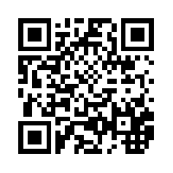 | 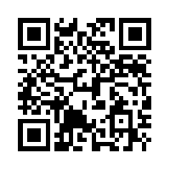 | 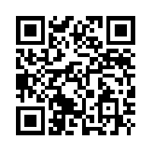 | 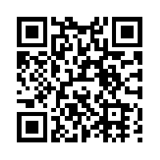 | 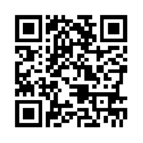

Slope: http://www.youtube.com/watch?v=O8fo4H_185g
Slope-Interceptform: http://www.youtube.com/watch?v=3t7E8PTfey0
Point-SlopeForm: http://www.youtube.com/watch?v=eHPTyYbNmx4
General Form: http://www.youtube.com/watch?v=BP6VhzU-piI
Parallel Lines: http://www.youtube.com/watch?v=mNa7RbXXZeg
PerpendicularLines: http://www.youtube.com/watch?v=mNa7RbXXZeg

Sec 1.2 Functions

Learning objectives (Read Pages: 16-23)
- Know the definition of a function.
- Be able to express answers in interval notation.
- Be able to find the difference quotient and simplify your answer.
- Be able to compose functions.
- Be able to evaluate a Piecewise-Defined function.

 | Def. Function | Piecewise-Defined function | Difference Quotient | Domain
Video | 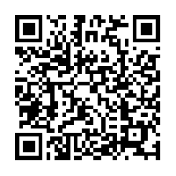 | 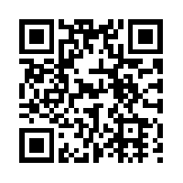 | 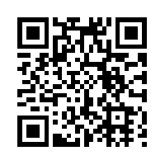  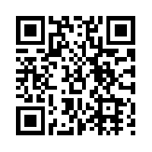  Example 2  Example 1 | 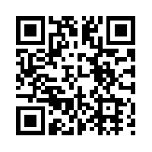

Def. Function: http://www.youtube.com/watch?v=0YreX1wYe_Y
Piecewise-Defined function: http://www.youtube.com/watch?v=3zHHidvbyak
Difference Quotient Ex 1: http://www.youtube.com/watch?v=1O5NEI8UuHM
Difference Quotient Ex 2: http://www.youtube.com/watch?v=v5P4y0OkED4
Domain: http://www.youtube.com/watch?v=w81y25anEOM

Sec 1.3 Graphs of Functions
Learning objectives (Read Pages: 29-36)
- Be able to determine the domain and range of a function.
- Be able to use the Vertical Line Test for functions
- Be able to determine the open intervals on which each function is increasing, decreasing, or constant.
- Be able to use a graphing utility to approximate the relative minimum and relative maximum of a function.
- Be able to graph piecewise functions.
- Be able to identify odd and even functions.
 | Domain/Range | Inc/Dec/Max/Min | Graph Piecewise fun. # 1 | Graph Piecewise fun. # 2 | Odd and Even functions
Videos | 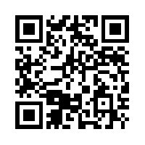 | 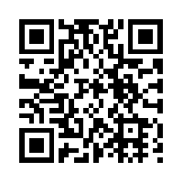 | 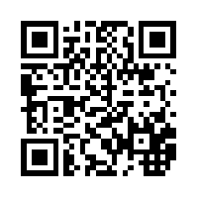 | 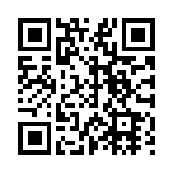 | 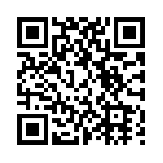

Domain/Range: http://www.cleanvideosearch.com/media/action/yt/watch?v=ObEucyZX464
Inc/Dec/Max/Min: http://www.cleanvideosearch.com/media/action/yt/watch?v=aJuJOB6NTuc
Graph Piecewise fun. #1: http://www.youtube.com/watch?v=gwffMEr8i8
Graph Piecewise fun. #2: http://www.cleanvideosearch.com/media/action/yt/watch?v=hDNAVh0VtTc
Odd and Even function: http://www.cleanvideosearch.com/media/action/yt/watch?v=oKKcIK_PgEk

Sec 1.4 Shifting, Reflecting, and Stretching Graphs
Learning objectives (Read Pages: 41-46)
- Be able to recognize graphs of parent functions.
- Be able to use vertical and horizontal shifts and reflections to graph functions.
- Be able to use nonrigid transformations to graph functions.
 | Shifts # 1 | Shifts # 2 | Reflections and Shifts | Nonrigid Transformations
Video | 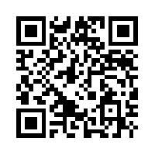 | 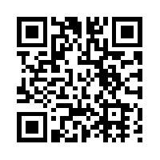 | 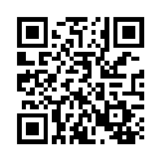 | 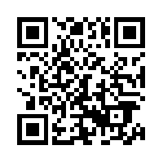
Shifts #1 https://www.youtube.com/watch?v=5oQgzup9nx4
Shifts #2 https://www.youtube.com/watch?v=h5HEs6krrE8
Reflections and Shifts https://www.youtube.com/watch?v=oHop0B4vEYU
Nonridgid Transformations https://www.youtube.com/watch?v=0gxksY57vps
Sec 1.5 Combinations of Functions
Learning objectives (Read Pages: 50-55)
- Be able to add, subtract, multiply, and divide functions.
- Be able to find compositions of one function with another function.
- Be able to use combinations of functions to model and solve real-life problems.
 | Arithmetic Combinations | Composition of Functions
Video | 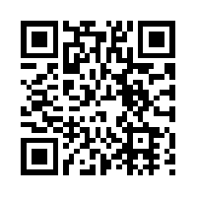 | 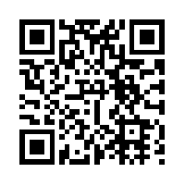

Arithmetic Combinations https://www.youtube.com/watch?v=I8Iul0Om-t4
Composition of functions https://www.youtube.com/watch?v=S4AEZElTPDo
Sec 1.6 Inverse Functions
Learning objectives (Read Pages: 60-66)
- Be able to find inverse functions and verify that two functions are inverse functions of each other.
- Be able to use graphs of functions to decide whether functions have inverse functions.
- Be able to determine whether functions are one-to-one.
- Be able to find inverse functions algebraically.
 | Finding Inverse Functions | verifying functions are inverse | one-to-one function
Video |  | 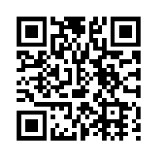 | 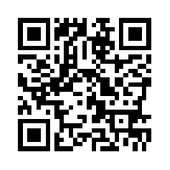

Finding Inverse Functions https://www.youtube.com/watch?v=Ec5YYVxyq44
Verifying functions are inverse https://www.youtube.com/watch?v=Ec5YYVxyq44
One-to –one functions https://www.youtube.com/watch?v=s02tm3veZk8

Sec 1.7 Linear Models and Scatter Plots
Learning objectives (Read Pages: 71-75)
- Be able to construct scatter plots and interpret correlations.
- Be able to use scatter plots and a graphing utility to find linear models for data.
 | construct scatter TI | linear models for data
Video | 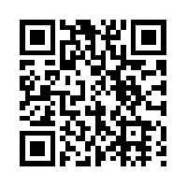 | 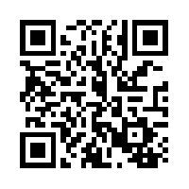

Construct scatter plot TI https://www.youtube.com/watch?v=bqEnt6oRwho
Linear models for data https://www.youtube.com/watch?v=qaecfKTa1cA

